ARDATH M. CADE SCHOLARSHIP FUND

Ardath M. Cade is a champion of affordable housing and community development, both throughout the State and here in Anne Arundel County. It was during her tenure as a county official that she helped launch the creation of Arundel Community Development Services, Inc. (ACDS), the County’s nonprofit housing and community development agency.

Thanks to Ardath’s vision, ACDS became more than just a privatized government agency, but a force for affordable housing and community development in Anne Arundel County. ACDS builds strong individuals, proud families and vibrant communities.

Sustaining and Growing the Legacy
The Ardath M. Cade Scholarship Fund will help continue the success of ACDS, as well as housing and community development initiatives throughout the County by growing future industry leaders. Scholarship recipients may include ACDS employees and Board members, or emerging leaders from the neighborhoods and communities we serve. Applications will be reviewed by a Scholarship Review Committee and, whenever possible, will leverage other funding sources. Professional development opportunities may include, but not be limited to:
- Housing counseling and foreclosure prevention assistance for staff
- Capacity building training for ACDS Board and senior management
- Internship Opportunities for young people interested in the field
- Neighborhood leadership training for community members
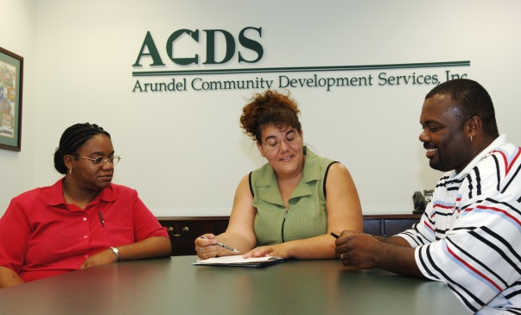

ACDS is a 501(c)(3) organization. Contributions to the Ardath M. Cade Scholarship Fund are tax deductible to the fullest extent of the law.
ARDATH M. CADE BIOGRAPHY

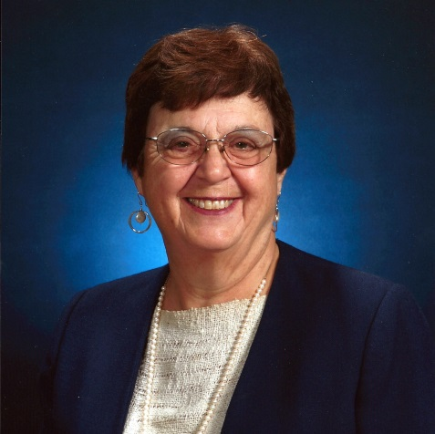
Ardath Cade is being honored for her 50 years in providing leadership and innovation for housing and community development in Maryland at the State and County levels, and advocating for Maryland at the federal level. She is widely recognized as a key person in the creation and implementation of numerous State and County housing and community development programs. Using her knowledge, experience, and tenacity, Ardath has the unique ability to identify needs and possibilities and bring together the resources, people, and politics necessary to accomplish the goals. Throughout her career, one thing about Ardath is clear—she is a dedicated public servant who gets things done and will not stop until she has.

Ardath started her government service in Maryland in Charles County as the County Administrator; while there becoming the first female member of the National Association of County Administrators and the organization’s President.

Joining the staff of Governor Blair Lee, she moved to the State level overseeing several departments, including housing and community development. Under Governors Harry Hughes and William Donald Schaeffer, she became Deputy Secretary of the Department of Housing and Community Development. In that capacity, she led the successful Housing Initiative of 1986 that established Maryland as a national leader in state funded housing programs, and established several innovative community development programs. Continuing her influence at the federal level, she served as President of the Council of State Community Development Officials.

Returning to County government, Ardath came to Anne Arundel County government, serving in several capacities involving housing and community development activities. She was key in launching Arundel Community Development Services, Inc. as an independent non-profit, a highly successful national model.

Capping her housing and community development career, she established the Cade Mason Group where she continues to work on various housing and community development projects and generously gives her time and expertise to groups such as the Maryland Affordable Housing Coalition. Her assistance to that organization helped create a major new housing program, for which she was honored with the President’s Award.

As Ardath celebrates her 80th birthday, she not only has had amazing professional achievements, but also has raised three remarkable sons and enjoys a close and loving extended family, and is a warm and caring friend to many.

