I

HOME PROGRAM

IN

ANNE ARUNDEL COUNTY

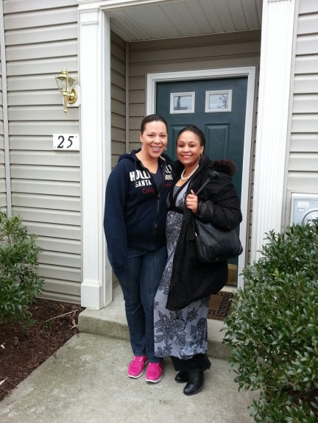
- Over $11,352,000 in HOME funding has been used to develop 1,335 affordable housing units for both low income families and low income seniors. It is estimated that every $1 in HOME funds leverages an additional $10 in LIHTC equity, local, State and private funds, producing jobs and supporting the local economy.

- Over $4,779,000 in HOME funding has been used to acquire or develop 21 group homes and rehabilitate 32 group homes so that persons with special needs and disabilities have affordable housing in a community setting.

- HOME has assisted nearly 413 low and moderate income homebuyers purchase their first home, with $6,138,348 in HOME funding, leveraging millions in State and private loan funds.

Anne Arundel County is an attractive community with good schools, workforce opportunities and exceptional access to recreation and the Chesapeake Bay. Because of its attractiveness, it is experiencing an affordable housing crisis, especially for low income renters and entry level workers. Right now, 41% of all low/moderate income renters and 41% of all low/moderate homeowners pay more than 50% of their income toward housing costs in Anne Arundel County. The situation is even more severe for extremely low income renters, 66% of whom pay more than 50% of their monthly income for housing. HOME is the primary tool we have for addressing this need at the local level and ensures that our workforce has affordable housing in areas of opportunity and that seniors can live in safe communities.

HOME Success Story: Elizabeth’s Long Road to Oakwood Family Homes

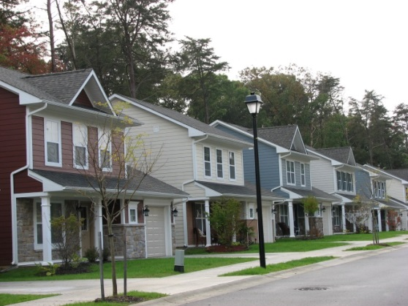
Elizabeth has had her share of hardships in her 61 years, but they have not made her give up hope. In 1998, she was in a terrible auto accident that left one of her two daughters dead and the other severely disabled. Elizabeth was also disabled herself as a result of the accident. Unable to work, she and her daughter moved in with her elderly father and her younger sister, who had been born with severe developmental disabilities and needed live in care. They resided in a comfortable six bedroom home in Arnold until her father’s death in 2007. When her father passed away, the reverse mortgage he had on his home required sale of the property and Elizabeth and her family were evicted as they were not able to pay the balance on the mortgage. By 2009, they were homeless and living in a van. In 2010, the family came in contact with Arundel House of Hope, which operates the Winter Relief Program. During the winter, they stayed in a different church each week at night time. During the summer, they lived in a tent in the woods in Glen Burnie. Elizabeth’s sister had suffered a fall and had to be committed to a nursing home/rehabilitation facility. In the meantime, Elizabeth got the family signed up on Housing Choice Voucher Program (formerly known as Section 8) waiting list, although the waiting list was years long. They continued to live in the woods and utilize Winter Relief until 2013, when Elizabeth spotted a Penny Saver ad for affordable rental units at Oakwood Family Homes in Glen Burnie. Not only were the homes affordable, thanks to subsidies through the federal HOME and Low Income Housing Tax Credit Programs, they also had a supply of accessible units specially designed for households with mobility impairments. Finally, in February of 2014, the family was reunited and able to move into their fully accessible unit at Oakwood Family Homes.

When asked her favorite part about her new home, Elizabeth said, “After living in a tent, we now have the space to be away from each other, but a home where we can all live together.” Finally re-united with her sister, who is in a wheelchair, Elizabeth and her daughter are ecstatic about their housing situation and glad that their family’s perseverance to stay together paid off. “I came from an upper middle class family and I lost everything in a blink of an eye. It just shows that everyone is one crisis away from being in the woods.”

Oakwood Family Homes
Oakwood Family Homes is a 22 unit affordable housing development consisting of one and two story single family homes serving low income families earning 60 percent of area median income or less. Located in the Glen Burnie community in Anne Arundel County, Maryland, the project is under a Lease Purchase Program, where the homes will be rented for 15 years, after which the resident will have the option to purchase. The project, which was developed by PIRHL, LLC., received a $670,000 low interest HOME loan through Arundel Community Development Services, Inc., which leveraged $1,181,635 in private loans and developer equity, $940,000 in State funds, and $5,531,590 in federal low income housing tax credit equity.

Arundel Community Development Services, Inc.
ACDS is a nonprofit organization located in Anne Arundel County, Maryland dedicated to serving low and moderate income households through affordable housing and community development. ACDS, which administers the HOME program on behalf of the County, utilizes an annual allocation of approximately $540,000 in HOME dollars, $270,000 in County match dollars and approximately $250,000 in HOME Program Income to provide first time homebuyer assistance and owner-occupied rehabilitation, as well as the development of affordable rental units. In addition to providing housing for the workforce and seniors, the HOME program provides jobs and supports the local economy.

Contact: Kathleen M. Koch, Executive Director, 410-222-7606, kkoch@acdsinc.org.

K:\Planning\Planning Documents\ABCD\HOME Success Story 2017.docx

