CDBG PROGRAM

IN

ANNE ARUNDEL COUNTY

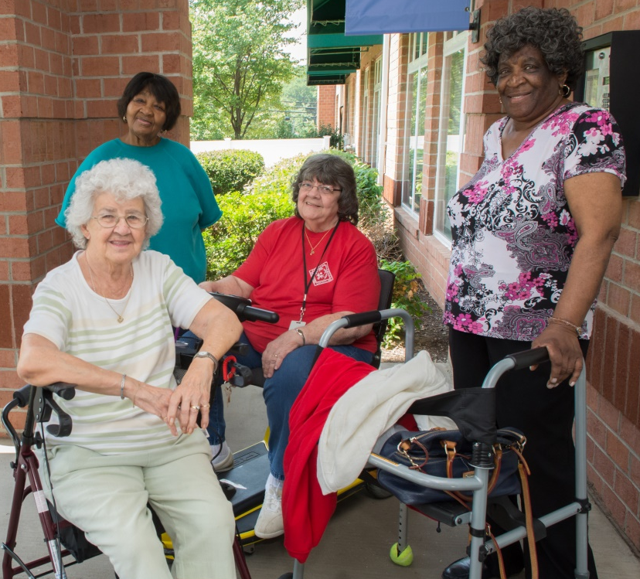
The Community Development Block Grant (CDBG) Program brings over $47 million in funding to Maryland communities annually, helping to address poverty and unique community development challenges, providing critical public services and addressing our affordable housing crisis.

CDBG provides approximately $1.8 million to Anne Arundel County alone each year, leveraging over $2 million in other sources, including local, state and private funding. Arundel Community Development Services, Inc. (ACDS) and at least 20 nonprofit and government partners, relay on CDBG funds to tackle a range of needs, from afterschool programs for youth, programs that allow seniors to stay in their homes, homeless prevention programs, to property rehabilitation programs and affordable rental housing production. A few highlights from Anne Arundel County’s FY2016 accomplishments – which could not have happened without CDBG – include:

- 250 families were prevented from being homeless through eviction prevention services

- 250 elderly persons were able to age in place thanks to assistance they received through a congregate services program operated by Catholic Charities and Partners in Care Repairs with Cares program

- 32 low income homeowners received comprehensive rehabilitation assistance to stabilize their homes

- Nearly 300 low income youth received afterschool and summer enrichment through programs like the Boys & Girls Clubs of Annapolis and Anne Arundel County

- As part of our neighborhood revitalization efforts, renovation work was completed on Brooklyn Park rowhomes, bringing the total number of homes transformed in Brooklyn Park to 36 owner-occupied homes and 34 affordable rental units

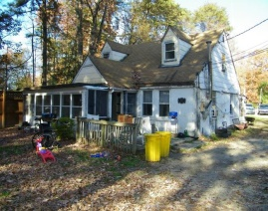
CDBG Success Stories

Senior Caregiver Gets Help Bringing Her Home Up to Standards
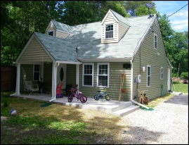
Arundel Community Development Services, Inc.’s Property Rehabilitation Program provides critical funding and construction management support to low income homeowners living throughout Anne Arundel County to make major repairs and bring their homes up to a livable, sanitary condition. The Program, which has helped rehabilitate over 500 homes allows families to stay in their homes and preserves affordable, sustainable housing.

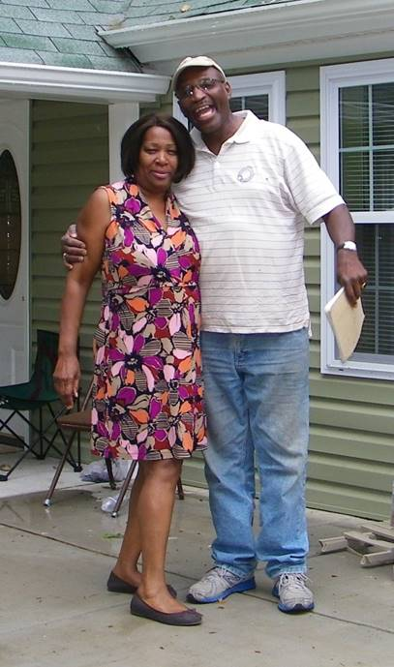
Mrs. Smith, a single elderly Pasadena resident was the sole caregiver for her three young grandchildren and bedridden aunt, when she contacted ACDS for help with her home, which had been in her family since its construction in 1952. The original, hand dug septic system had failed and raw sewage was overflowing in her yard. Meanwhile, the home was heated with a woodstove, had original windows, which needed to be covered with plastic, and had an outdated and hazardous electrical system. Thanks to a deferred CDBG funded loan, and CDBG supported construction management from ACDS, the home underwent major renovations and Mrs. Smith, a caregiver for adults with disabilities by profession, and her family were able to stay in their home with much improved conditions at an affordable cost, while the children could stay in their school.

“Without this Program, I would still be worrying about who would bring in the firewood to heat the home or worrying if the electric was going to go out and spoil my food. The children love it, it has made living a whole lot better!”
- Mrs. Smith, April 4, 2017

Kids Like RJ Get the Support They Need to Thrive
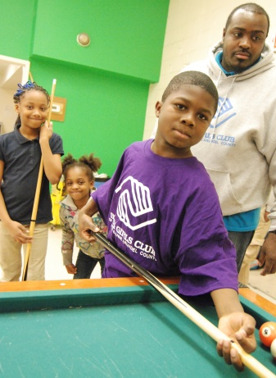
RJ is just one of more than 300 low income Anne Arundel County youth who are able to attend quality, afterschool programming supported by the CDBG Program. At the Meade Village Boys & Girls Club in Severn, Maryland RJ and his peers have a safe place to call home, a hot meal, help with school, mentors and programs which are proven to help youth and teens navigate life and keep them on the path to successful futures. RJ’s mom credits this program with building RJ’s self-confidence and raising his expectations for the future. RJ now loves reading and his grades have improved thanks to the Program’s homework help and mentoring services. CDBG funds also support youth at the Freetown Village Boys & Girls Club and the Brooklyn Park Teen Clubs each year and provided capital support to develop the Boys & Girls Club Regional Club at Wiley H. Bates Heritage Park.

Historic Landmark Restored to Former Glory; Re-Emerges as a Source of Support for Community
For 25 years, from its closing in 1981 to its grand reopening in September 2006, the struggle to renovate the Wiley H. Bates High School – once Anne Arundel County’s only high school for African American students during segregation and the center of cultural life for its students and their families - represents the unwavering determination and dedication of the local African American community. Their dedication would not have been rewarded were it not for the federal CDBG funds.

In 2000, the Bates building was boarded-up windows, crumbling walls, overgrown fields and flooded corridors. The building sat unused, until the grand reopening in 2006. The $27 million dollar renovation and adaptive reuse of this 124,000 square foot building was completed with funds coming from 11 different public and private sources; $2,330,000 in CDBG funds leveraged $24,670,000 in other state, County, and private funds.

Today, the renovated school stands as a monument to a distinguished generation of African American administrators, teachers, and students. Renamed, the Wiley H. Bates Heritage Park, today the community landmark offers affordable senior housing, a senior activity center, a Boys & Girls Club, and the Bates Legacy Center, a museum dedicated to this landmark’s rich history.
CDBG Success Stories

Bacontown, Laurel, Maryland
Bacontown is a historically significant African American community in Anne Arundel County located along Whiskey Bottom Road north of Laurel, Maryland. Bacontown got its name from Maria Bacon, who was deeded the property shortly after she was freed from slavery in 1860. It grew into a thriving hamlet of three dozen houses and trailers, with its own little white church and a tiny school. However, the 1980’s brought drugs dealers and prostitutes, along with a deteriorating housing stock and inadequate water and sewer facilities.

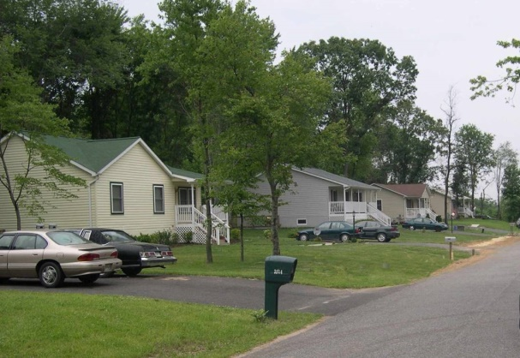
In concert with the community, a comprehensive revitalization plan was developed in the 1990s, which began with a major community clean-up effort involving hauling away of old cars, trash and abandoned trailers. The revitalization efforts developed into a 10 year undertaking, moving the community from a forgotten hamlet to a thriving modern community. This could not have happened were it not for CDBG funds.

Working closely with the residents and making strategic use of CDBG funds and leveraging those resources with State, County and private funds, the ambitious revitalization included the installation of new public water and sewer facilities, road improvements, and the renovation of 18 owner-occupied homes. In addition, nine vacant parcels of land were purchased and affordable homes for first time homebuyers were constructed. Homeownership counseling and closing cost and downpayment assistance was provided to the new homeowners, many of whom had roots to the Bacontown community. New homeowners also participated in a program sponsored by Leadership Anne Arundel that equipped them with the skills to engage and lead their community. Thanks to the CDBG funds and the involvement of a strong community, today Bacontown is a replicable model of a successful revitalization effort.

Tenthouse Creek Village, Galesville, Maryland
The renovation of the Tenthouse Creek Village, along the West River in Galesville, was part of a community wide revitalization plan developed in concert with local residents. This small enclave dates back to the purchase of land by free African-Americans prior to the Civil War. From the 1920’s to the 1970’s, many of the residents were employed by the Woodfield Fish and Oyster Company as waterman and oyster shuckers. By the early 1990’s, the residents of the community were no longer employed by Woodfield’s due to the dying oyster population in the Chesapeake Bay; however, many families continued to live in homes owned by the Woodfield’s, as they had for generations.
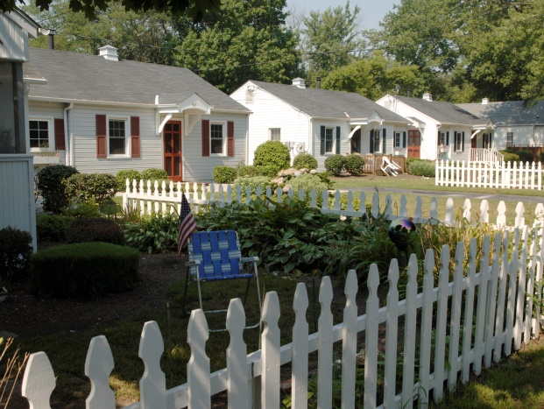
Prior to redevelopment, residents had to “tote” water from nearby outdoor wells and use common outhouses. Many of the original wood frame “shanty” houses were replaced in the 1950’s with four room cinder block structures each heated by a kerosene space heater. By the 1990’s, these masonry structures without any indoor plumbing were substandard and dilapidated. With the installation of public sewer in the community, County code required the 16 houses owned by the Woodfield’s be brought to current code standards. As the Woodfield’s rented the units for less than $25 a week, they could not afford the required improvements and were faced with rising pressure to sell the land for luxury waterfront development.
Rather than demolishing the units and displacing the residents, at potentially a much higher profit, the Woodfield’s agreed to sell the property to a local nonprofit organization that secured CDBG and HOME funds from the County and leveraged those funds with State and County funds to complete rehabilitation and an expansion of each unit to add kitchens and bathrooms. In addition, CDBG funds were used to help the homeowner’s in the community hookup to the water and sewer facilities. Twenty years later, the community is still a vibrant affordable community.
K:\Planning\Planning Documents\CDBG and HOME Advocacy\cdbg 2017.docx

