ACDS INCOME LIMITS
Unless otherwise noted, the income limits below are effective as of June 15, 2023 and are taken from the HUD Area Median Income Limits (adjusted for household size) for the Baltimore Metropolitan Area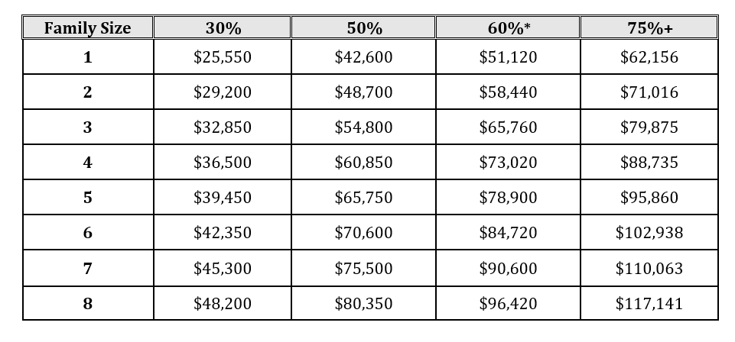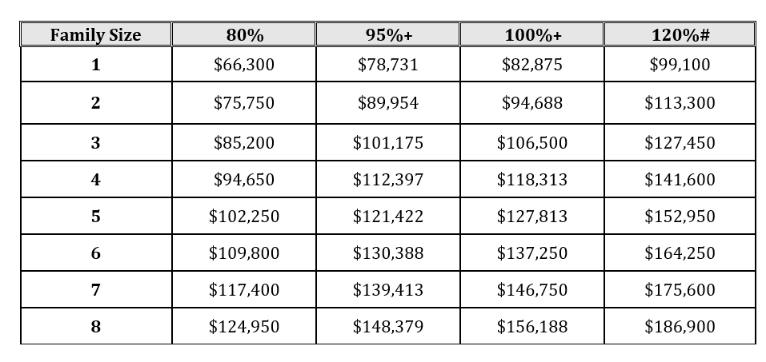
* Based on 2023 HOME Income Limits as published by HUD and made effective as of June 15, 2023
+ Income limits calculated by ACDS staff based on NSP 120% AMI limits for Anne Arundel County as published by HUD and effective as of June 15, 2023
# NSP Income Limits for Anne Arundel County as published by HUD and effective as of June 15, 2023

