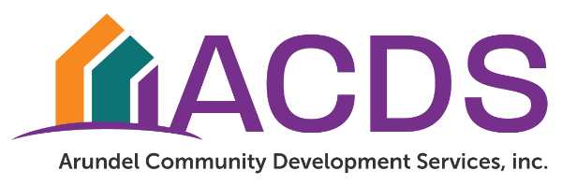

NEIGHBORLY SOFTWARE
User Guide

Arundel Community Development Services, Inc.
Erin Karpewicz, Chief Executive Officer

ii
TABLE OF CONTENTS
Registering for Software ................................................................................................................................................... 3
Account .................................................................................................................................................................................. 4
Reports .................................................................................................................................................................................. 5
Progress Reports .................................................................................................................................................................. 5
Accomplishments..................................................................................................................................................................... 6
Draw Requests........................................................................................................................................................................ 6
Draw Request Edits……………………………………………………………………………………………. 9
Status of Draw Request ........................................................................................................................................................ 10
Application .............................................................................................................................................................................. 11
Users ......................................................................................................................................................................................... 11
Tasks…………………………………………………………………………………………………………... 12
Example: Cover Letter…………………………………………………………………………………………. 13
Example: Invoice ……………………………………………………………………………………………… 14

REGISTERING FOR SOFTWARE
This section will help you set up an account if you have never accessed the system before. Each user should have their own unique log in credentials as all the activities in the system will be attributable to the user and documented in the audit log.

- Access the website at: https://portal.neighborlysoftware.com/ACDS/Participant/Login and bookmark it.
- Select the “Register” tab
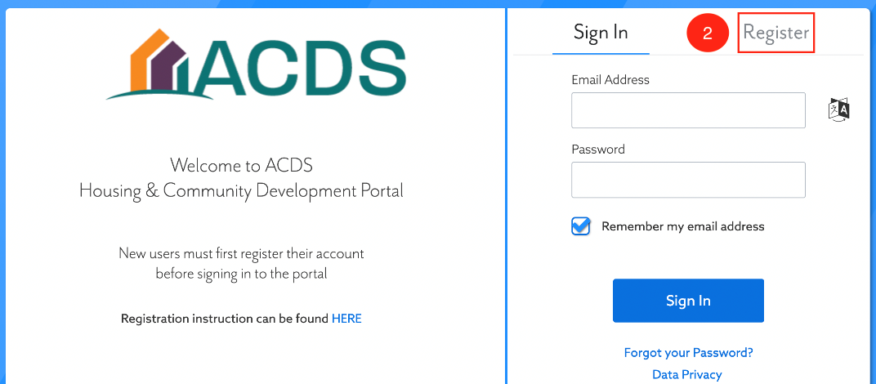
- Complete the form and select “Continue”

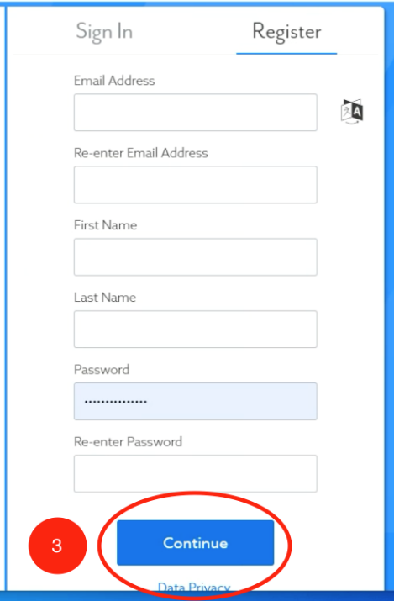

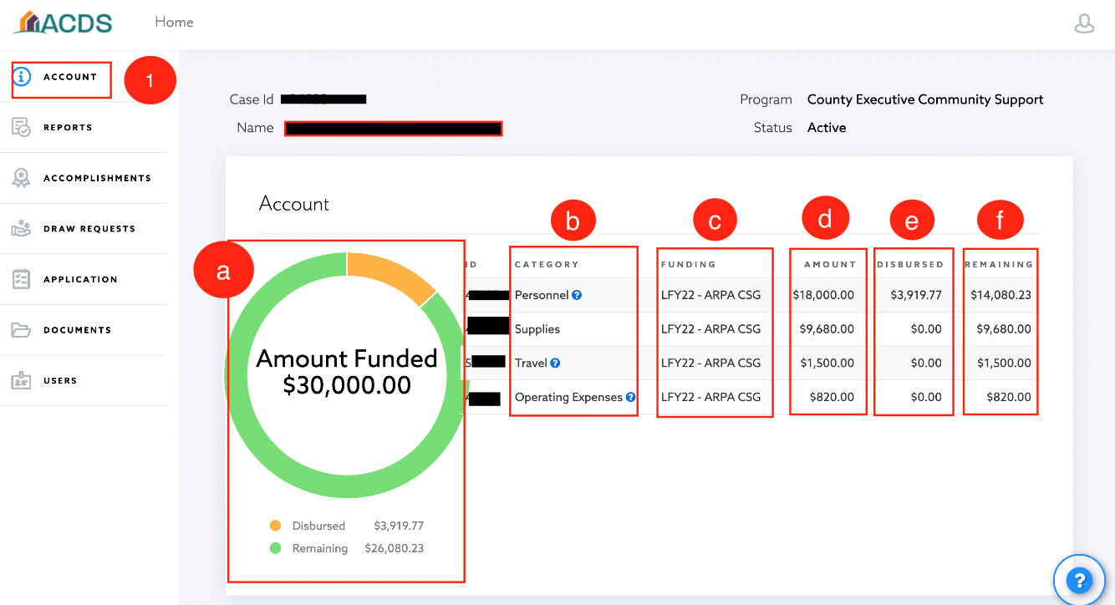

1. From the left-hand navigation pane select the “Account” tab. On this screen you can review the following:
a. Amount funded – total amount funded as well as the breakdown of funds that have been disbursed or are pending
b. Category – breakdown of eligible activities
c. Funding – source of funding (e.g. FY23)
d. Amount – amount funded in each category
e. Disbursed – amount disbursed by category
f. Remaining – remaining balance by category

REPORTS
THIS SECTION WILL SHOW HOW TO SUBMIT THE REQUIRED REPORTS.
Progress Reports
Progress reports are required at regular intervals throughout the lifetime of your grant. The subrecipient agreement will specify how often you are required to submit your progress report.
- From the left-hand navigation pane select the “Reports” tab.

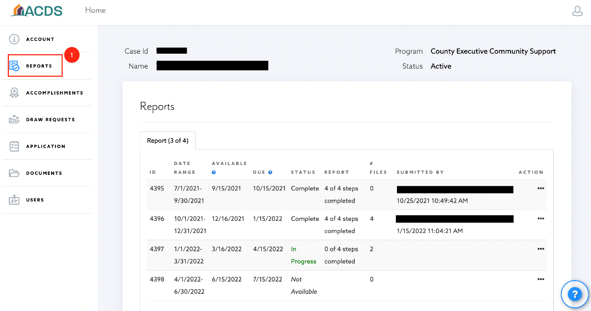

- Reports open on predetermined dates. You will receive an email notification when a report is opened. Click on the report that says “Available Now”.

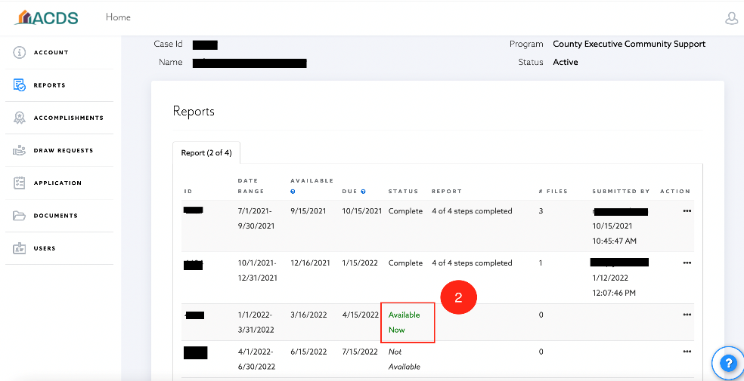
ACCOMPLISHMENTS
THIS SECTION WILL SHOW HOW TO VIEW THE MONTHLY AND CUMULATIVE NUMBER SERVED.
- From the left-hand navigation pane select the “Accomplishments” tab.
- Accomplishments will be listed by month and will show the total for all months combined.
- To export, click on the Excel icon.

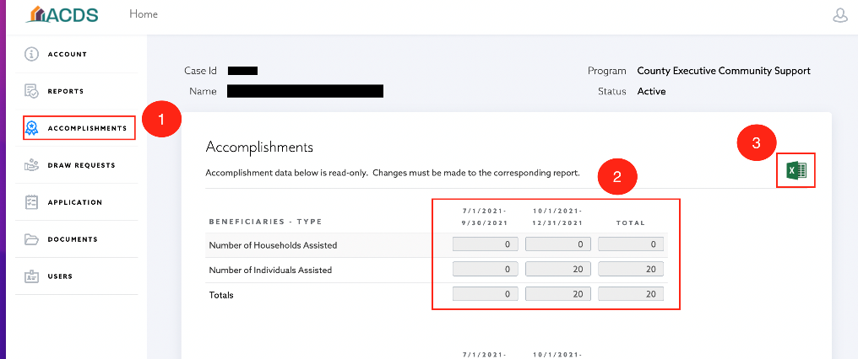

DRAW REQUESTS
THIS SECTION WILL SHOW HOW TO CREATE A DRAW REQUEST

- From the left-hand navigation pane, select the “Draw Requests” tab.
- Select “Add a Draw”

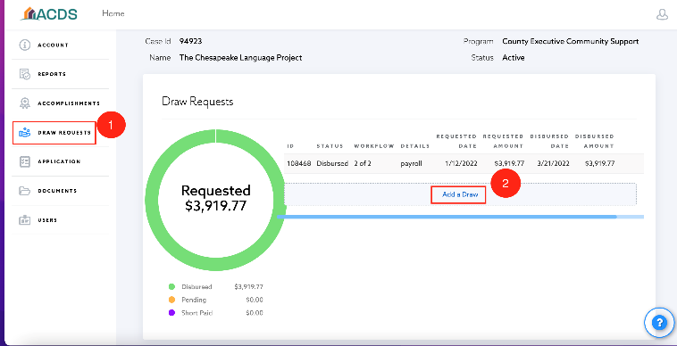

- The Request Date will automatically populate. In the “Description” field please follow this formula: “(draw number ex: 1st, 2nd, etc) for (total $ amount) for expenses incurred from (date – date)”.
Example: 3rd draw for $5,000 for expenses incurred from March 3, 2022 – April 1, 2022.
- Select “Add”

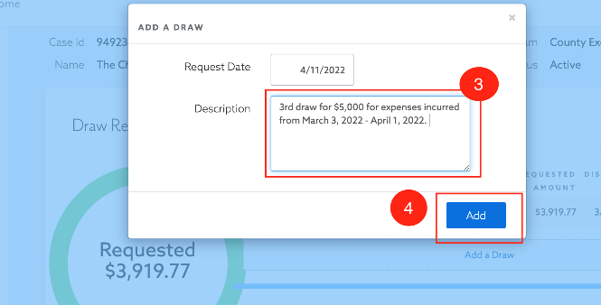
- Upload your cover letter/invoice and all supporting documentation as one PDF file. Select “Upload” and choose the file from your computer. (Find examples of the Cover Letter and Invoice at the end of this user guide).
- Enter the correct amount in the “Amount Requested” filed. This amount should match the amount shown on your cover letter/invoice and the supporting documentation.
- Click out of the box to make sure the correct amount shows in the “Totals” field.

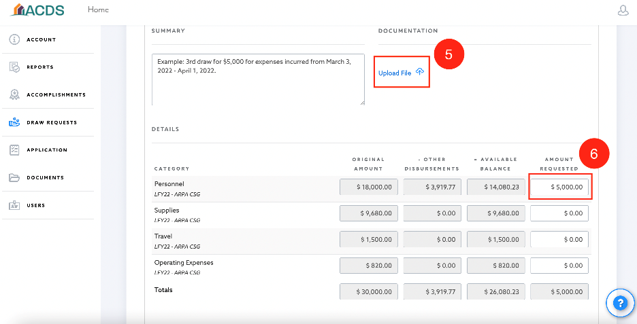

- Select “Submit”.

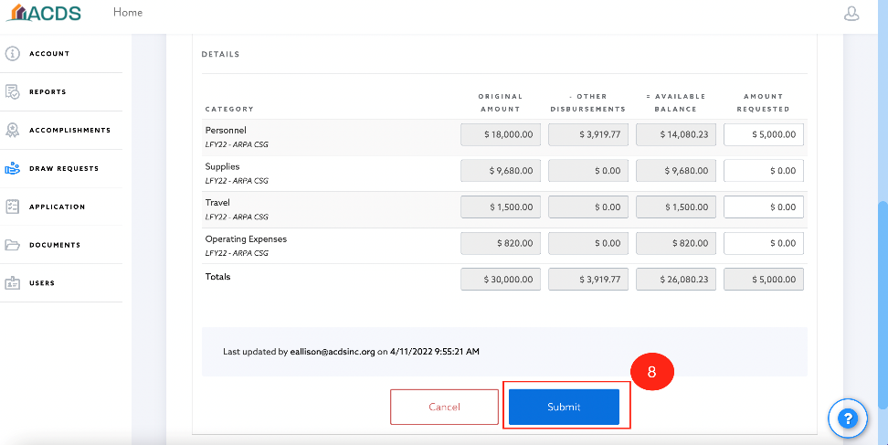

- On the pop-up select “Proceed” if the amount is correct. If not, select “Cancel” and correct the amount.

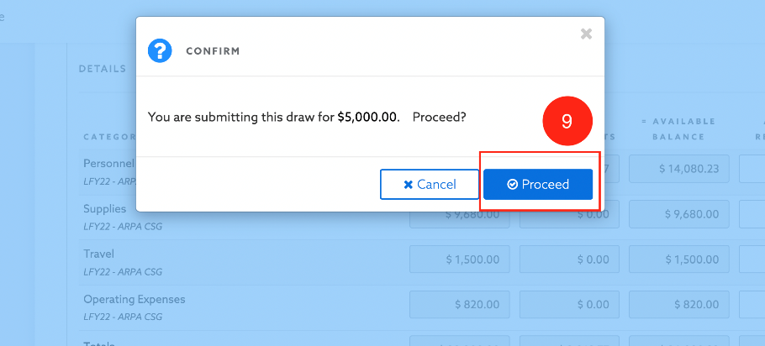

DRAW REQUEST EDITS
IF A DRAW REQUEST IS RETURNED TO YOU FOR ADDITIONAL INFORMATION, PLEASE FOLLOW THIS PROCEDURE.

- When you have the other documents to add, please enter your draw request and scroll all the way to the right.
- If you hover over the draw request, a blue door with an arrow will appear. Click the door to edit your existing request rather than starting a new one.

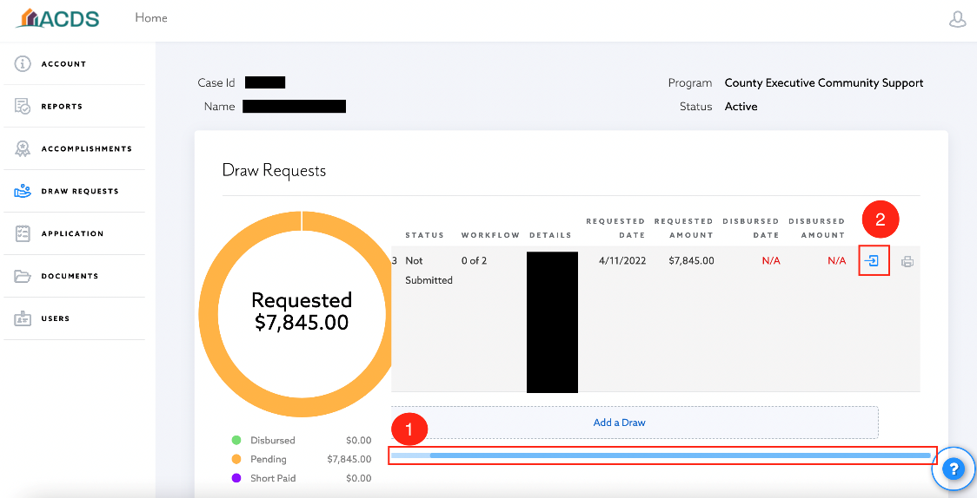

- When you have finished uploading the documents, click “Submit” as you did the first time.

STATUS OF DRAW REQUESTS
AFTER SUBMITTING A REQUEST, IT IS POSSIBLE TO CHECK ON THE STATUS. BELOW WILL SHOW WHERE TO VIEW THE STATUS AS WELL AS THE MEANING OF THE STATUS.

- From the left-hand navigation pane, select the “Draw Requests” tab. The system will take you to an overview of the budget.

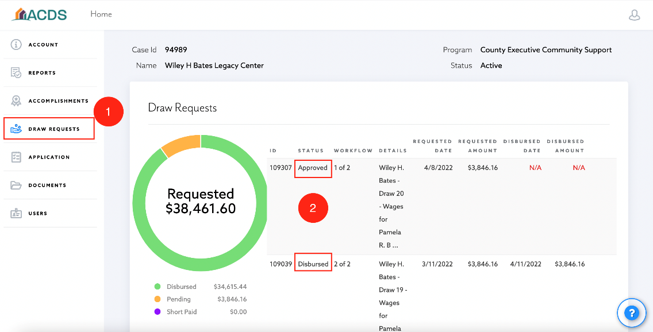

- The status will tell where the request is in the process:
  - Submitted – request has been submitted and is awaiting review by staff.
  - Approved- request has been approved by staff and is awaiting department approval.
  - Disbursed – request has been approved by department and the payment has been processed.

APPLICATION
THIS SECTION WILL PROVIDE INFORMATION ON VIEWING THE APPLICATION FOR THE ASSOCIATED GRANT.
- From the left-hand navigation pane click on the “Application” tab.
- It will display the various sections of the grant and you can click into each of these sections to view that portion of the application.

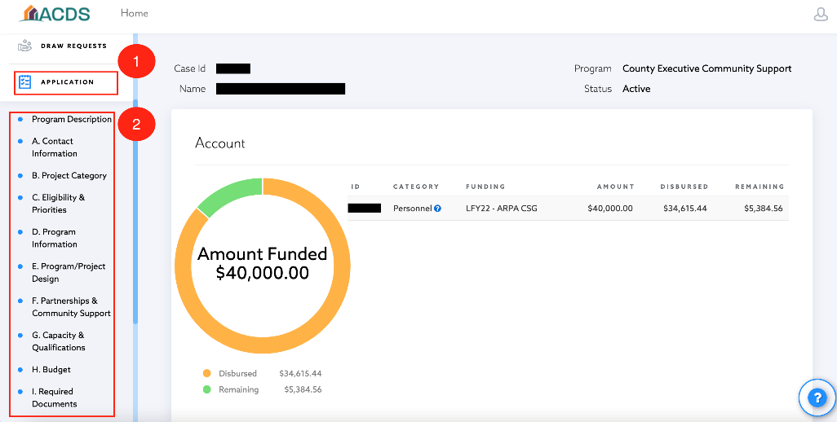
USERS
THIS SECTION WILL SHOW HOW TO ADD AN ADDITIONAL PERSON TO A PROJECT. ADDING USERS WILL ALLOW: MULTIPLE PEOPLE TO COLLABORATE ON AN APPLICATION, FINANCIAL REPRESENTATIVE TO COMPLETE A DRAW REQUEST FOR REIMBUSEMENT, ABILITY TO ASSIGN TASKS, ETC

- From the left-hand navigation pane, select the “Users” tab.
- Select the “Add a User” button.

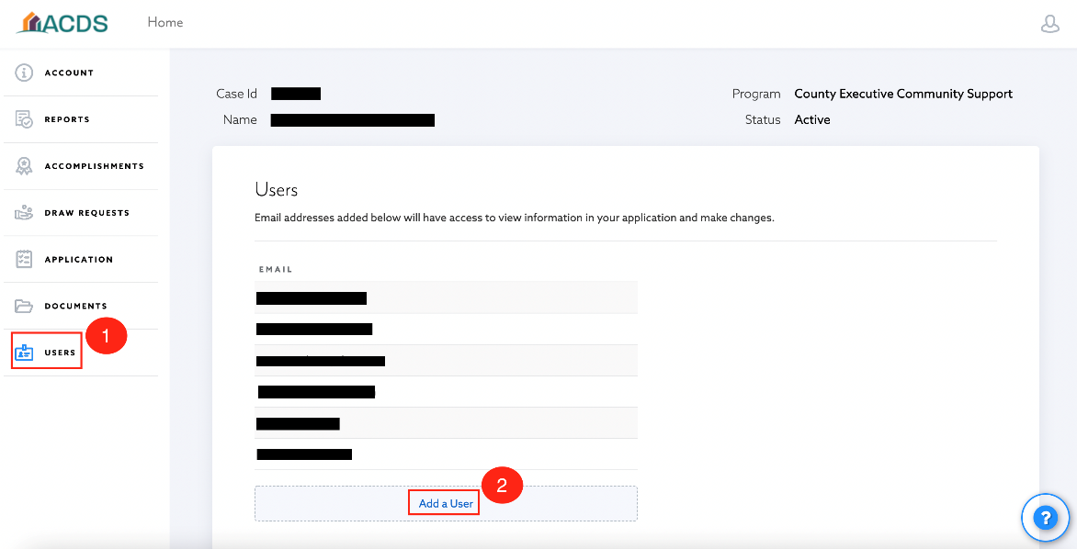
TASKS
THIS SECTION WILL SHOW HOW TO ADDRESS TASKS WHEN THEY ARE ASSIGNED.
- Log in to Neighborly
- In addition to your usual grant portal, you’ll see an active task to complete. Click on the task.
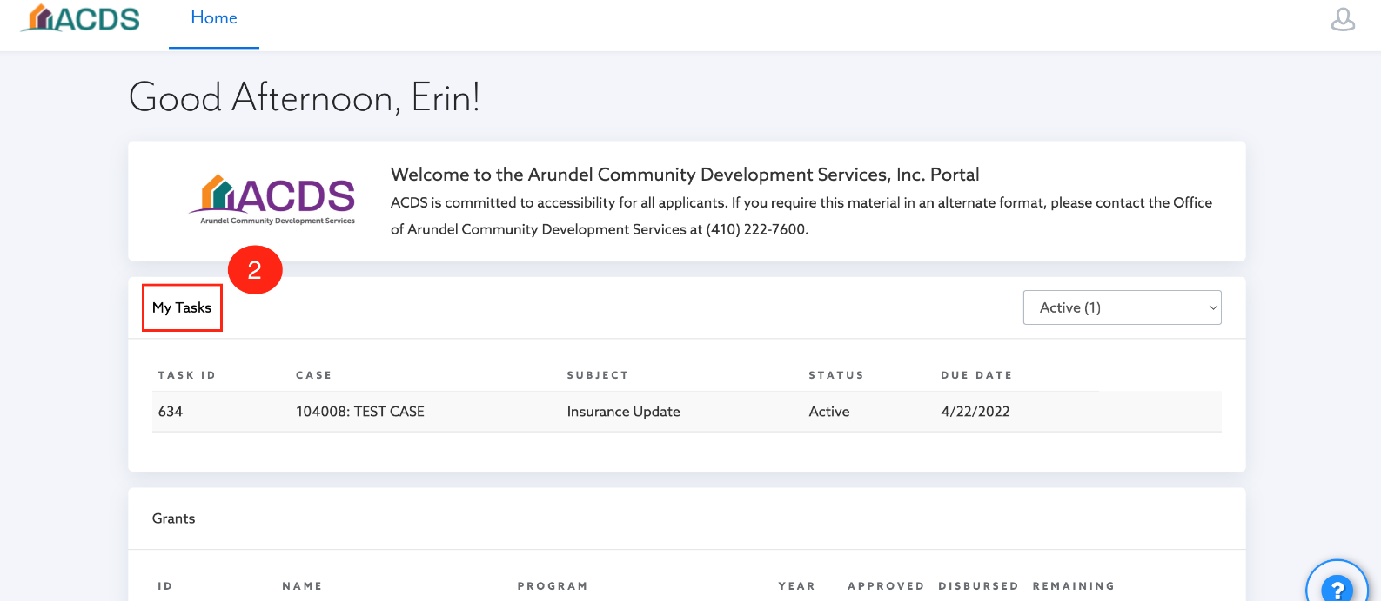
- Complete the task. If uploading a document is required, you can do that here.
- Click the drop down menu in the “Status” box and select “Complete”.
- Then click save.

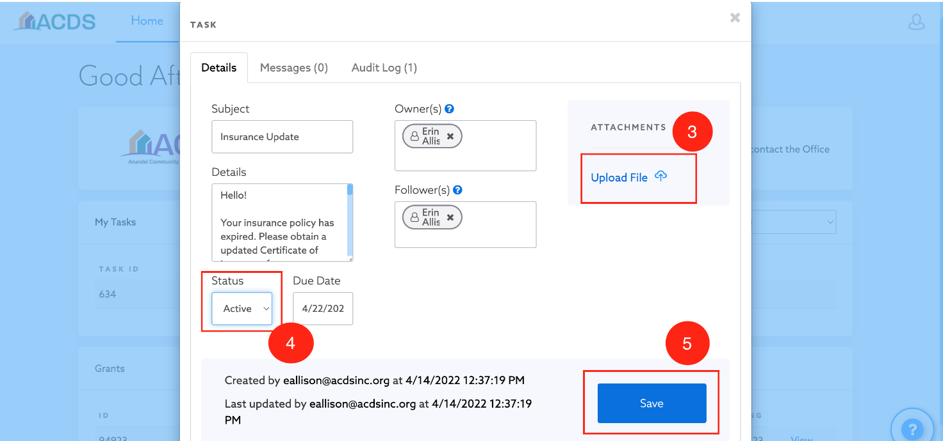

Cover Letter Example
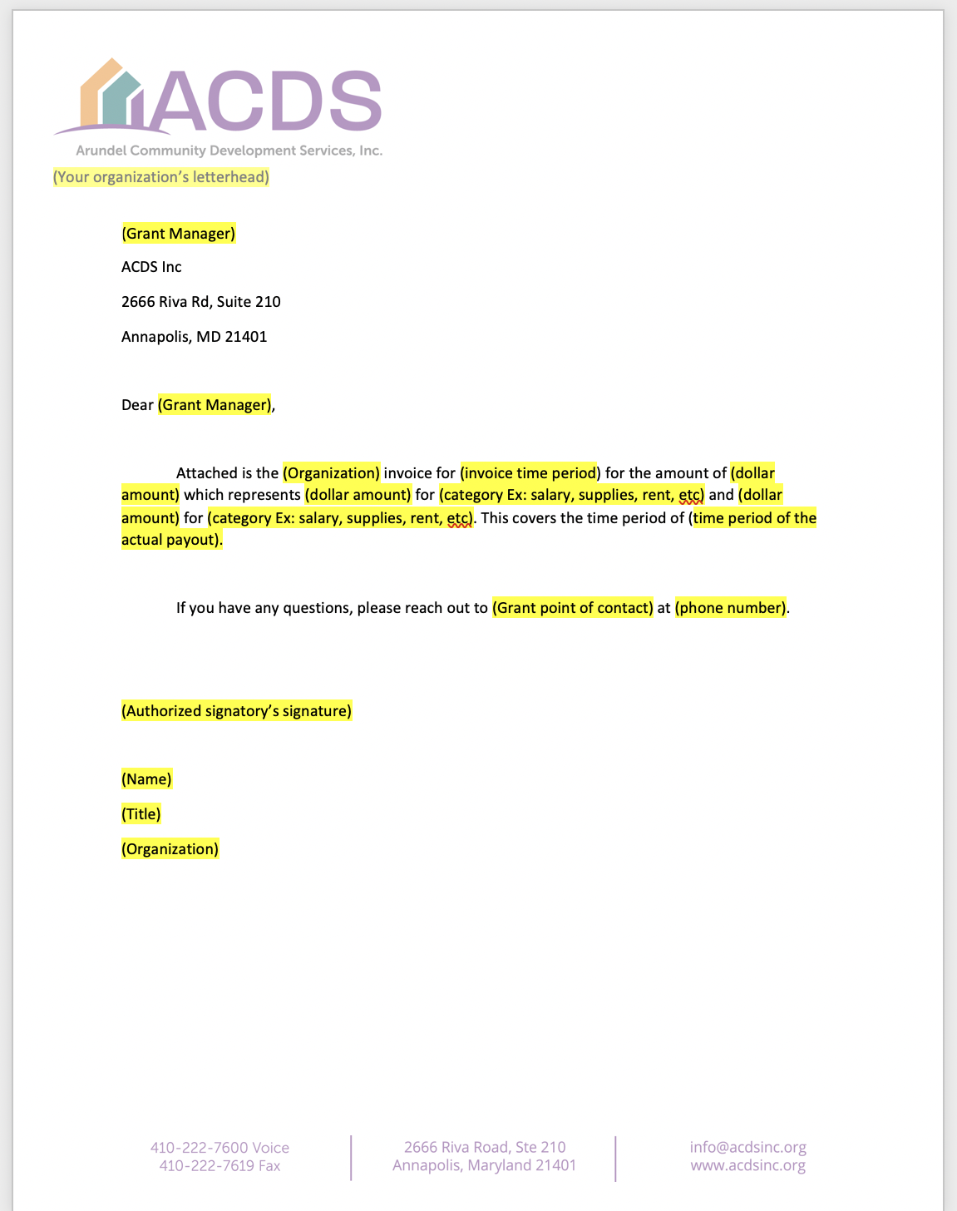

Invoice Example
